IMMEDIATE PRESS RELEASE

Baybars Altuntas of Turkey receives Top European Award:
Best Individual in Europe Globally Engaging Within the World’s Entrepreneurial Ecosystem!

(Eindhoven)- Baybars Altuntas of Turkey has been awarded second time as Europe's best individual in globally engaging the early stage investment market within the entrepreneurial ecosystem at a gathering of more than 200 high net worth individuals from across Europe and the US in Eindhoven this week.
Altuntas has been recognised at the tenth annual EBAN awards, which ran alongside the 15th annual European Business Angel Congress.The conference brought more than 200 elite business angels and investors from across Europe and the US to Eindhoven Tehchnology Park.

European Awards of EBAN
As part of the EBAN annual Congress, EBAN hosted the 10th EBAN Awards Ceremony taking place in Eindhoven, on the evening of May 7th, 2015. This event celebrate individuals and organisations that have made a successful and significant contribution to the early stage investment market in Europe in 2014. The best in Europe is being honoured every year by EBAN.

Altuntas was given a personal audience by President Obama
Baybars Altuntas was one of the 150 entrepreneurs invited by President Obama for the Presendential Summit on Entrepreneurship in 2010. Altuntas was the only entrepreneur given by personal audience by President Obama before the summit at the White House.He is a very succesful entrepreneur and angel investor who set-up his 50 million dollar valued company, Deulcom International, from scratch while he was a university student. He is also one of the dragons of the Dragons’ Den, a worldwide known TV show on entrepreneurship. His best-seller book ‘Off the Bus! Into a Supercar’ has been translated into many languages. He is an idol of university students willing to be succesful entrepreneurs in the future.
Altuntas is awarded by EBAN the second time. He was recognised as the 2013’s Best Individiual in Europe Globally Engaged Within the World’s Entrepreneurship Ecosystem last year in Dublin. The same award again went to Altuntas, the President of TBAA – Business Angels Association of Turkey, this year in Eindhoven.
EBAN represents a sector estimated to invest 7.5 billion Euros a year
EBAN is the pan-European representative for the early stage investor community, gathering 111 member organisations in 39 countries today. Established in 1999 by a group of pioneer angel networks in Europe with the collaboration of the European Commission and EURADA, EBAN represents a sector estimated to invest 7.5 billion Euros a year and playing a vital role in Europe’s future, notably in the funding of SMEs and creation of wealth and jobs.
For additional information contact the EBAN Secretariat.:
Director of Secretariat of EBAN
info@eban.org
www.eban.org
CorkBIC was delighted to be awarded Best performing New EBAN member for 2015
As part of the recent EBAN 2015 Angel Summit, the EBAN Awards Ceremony took place in the Evoloun, on the evening of 7th May 2015. This special event celebrates individuals and organisations that have made a successful and significant contribution to the early stage investment market. The best in Europe were honoured at this exciting event!
CorkBIC was delighted to be awarded Best performing New EBAN member for 2015. Speaking after the awards, Eileen Moloney, CorkBIC said "I am thrilled to accept this award on behalf of CorkBIC in recognition of the growing collaboration between CorkBIC and EBAN. Part of CorkBIC's core activity is to assist start-ups seeking investment and a growing number of these start-ups are looking beyond Ireland for Angel Investment."
The EBAN 2015 Angel Summit was a three day event attended by more than 300 representatives of the early stage financing industry and entrepreneurs from all over the world. The event took place at the High Tech Campus in Eindhoven, the Netherlands, Europe’s leading innovation hub and R&D center, from the 6-8th of May. EBAN 2015 Angel Summit, centred on the theme of creating, financing and building global success stories made in the EMEA region, welcoming business angels, family investors, VC funds, business accelerators, seed funds and venture philanthropists to interact with entrepreneurs from all over Europe and the World.
Michael O'Connor, CorkBIC drove the EBAN e-Xcelerator Venture Academy with investors and 25 growth companies while Eileen Moloney, chaired a session during the conference on Expanding the Venture Finance Eco-System with Corporate Venturing and Business Accelerators.
Michael is co-chair of the EBAN Accelerator Committee or e-Xcelerator, working to develop a working alliance between Accelerators that invest in companies and Business Angel Networks across Europe. Accelerator founders seek the finest well connected Business Angels to mentor and invest and those running Business Angel Networks seek the finest well prepared growth companies.
For more information on EBAN go to: www.eban.org
For more information on CorkBIC go to: www.corkbic.com
CorkBIC is a member of EBAN - The European Trade Association for Business Angels, Seed Funds and Early Stage Market Players

2014 EBAN Awards

Congratulations to the Winners
The EBAN Awards ceremony took place during the Gala Dinner on evening of the 7th of May at the Evoluon Conference Center in Eindhoven, the Netherlands.
EBAN recognised European Business Angel Federations, Networks and Investors who have demonstrated excellence and commitment to driving business angel investment over the last year. Furthermore, MBAN awards were granted for the first time for two different categories and also two special recognition awards were assigned to the organizations and individuals actively engaged in the angel investment community. Paulo Andrez, President Emeritus of EBAN, joined President Candace Johnson in bestowing the awards.
The distinguished Winners of the 2014 EBAN Awards are:
1. Lifetime Achievement Award: Peter Jungen
Peter Jungen has dedicated the last two decades to the finance of innovation and growth by entrepreneurial companies in Germany, Europe and the world. He is most likely the person who has done the most to bring about a “new economy” where private investors, entrepreneurs, and policy makers create “Capital value” for the 21st century. [Read full press release]
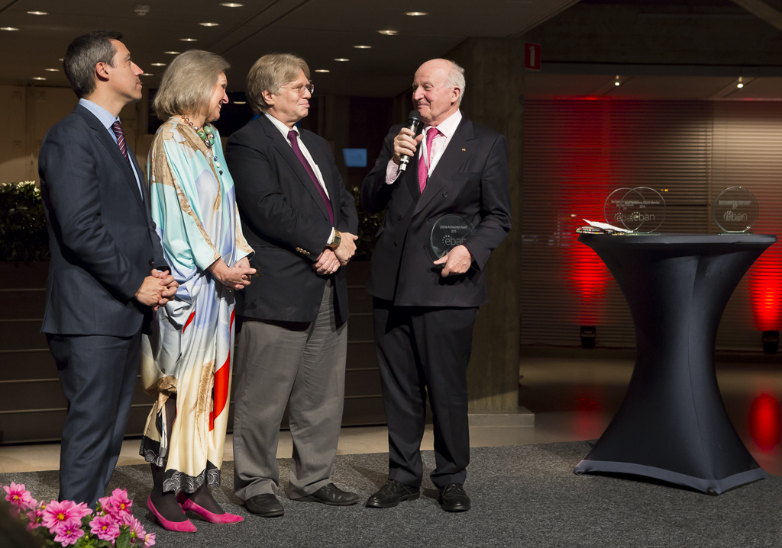
2. Best European Early Stage Investor 2014: Brigitte Baumann
Brigitte holds a portfolio at Go Beyond Early Stage Investing of 28 early stage companies in different countries (US, France, Belgium, Germany, Switzerland, India, Australia, New Zealand, Israel and Spain), in different sectors (ICT, Industrial, Finance, Impact, Sharing economies) and has had 2 successful exits in the last 12 months. First, Sensima in July 2014 and Lemoptix, aquired by Intel in March 2015. [Read full press release]
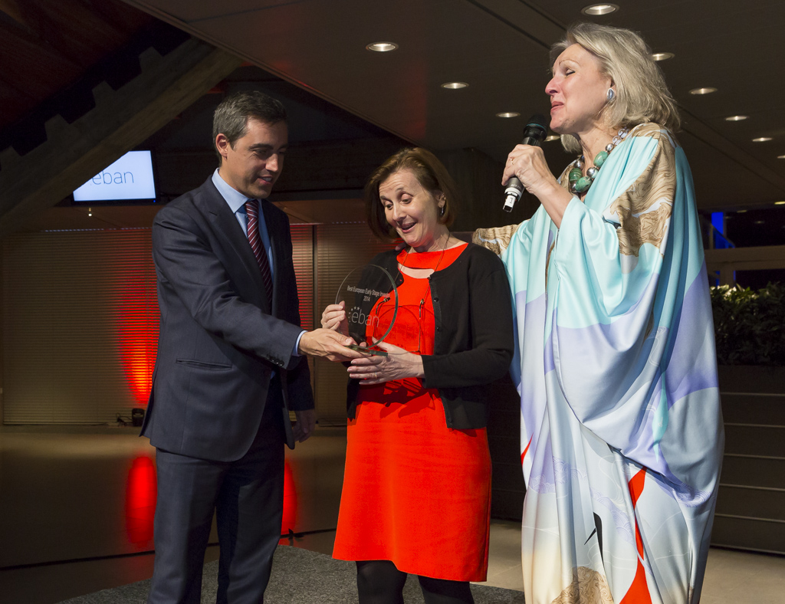
3. Best Performing EBAN Member 2014: Finnish Business Angel Network (FiBAN)
FiBAN made an amazing 31 million Euros of investment during 2014 and had more than 10 exits, all the while organizing EBAN's biggest ever Winter University in Helsinki with SLUSH! Congratulations to the entire FiBAN Team!
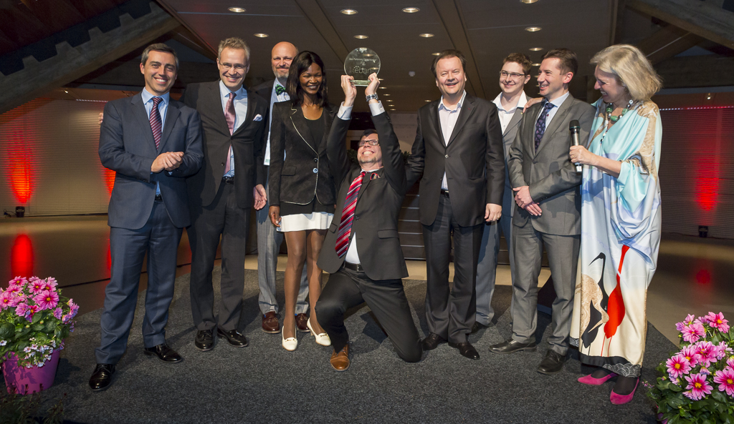
4. Best Performing EBAN New Member 2014: CorkBIC
CorkBIC has done a great deal to develop the Accelerator Community with the EBAN Membership. Together with Daniel Tomov of Eleven, CorkBIC co-chaires the Accelerator Committee of EBAN and is a wonderful new member. Eileen Moloney accepted the award on behalf of CorkBic and its CEO, Michael O'Connor.
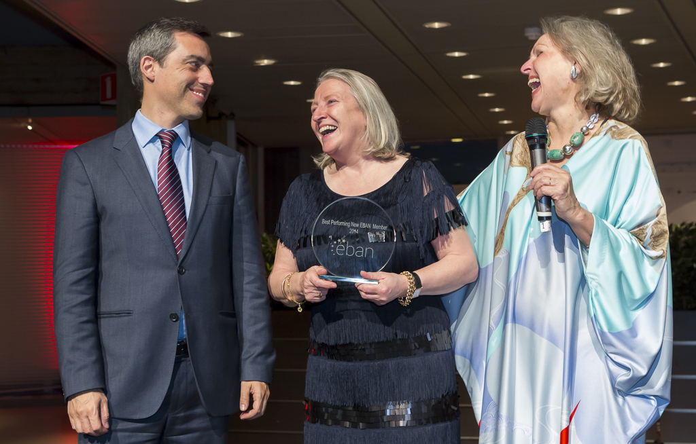
5. Best Business Angel Week Initiative 2014: Invicta Angels
Invicta Angels organized numerous events during the Business Angel Week 2014 and did it with passion and gusto! Congratulations!
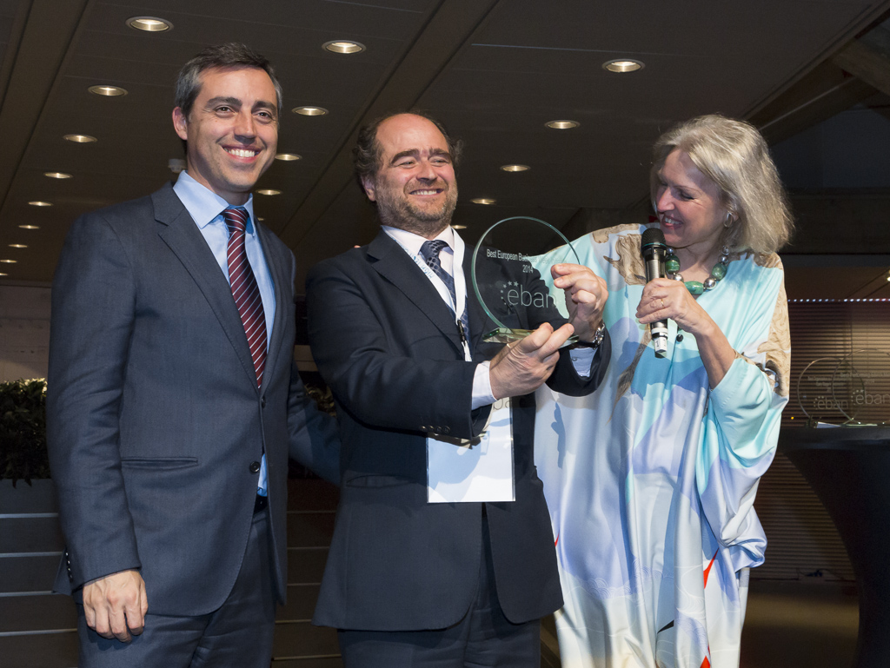
6. Best Individual/Organization in Globally Engaging the Early Stage Investment Eco-System: Baybars Altuntas
Baybars Altuntas has won this award for the second time in a row for his tireless promotion of the Early Stage Investment Eco-System around the world. Congatulations Baybars!
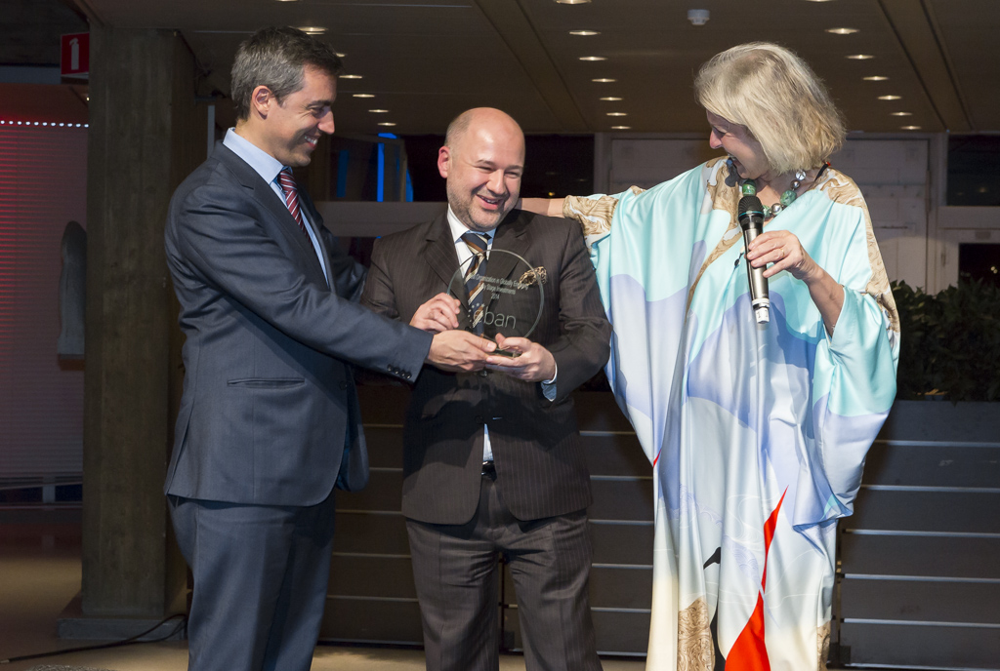
The distinguished Winners of the MBAN Awards are:
1. Successful Business Financed by Early Stage Investors: Wezi Wezi
We were pleased to have our partners MBAN participate for the first time in the awards and to welcome Wezi Wezi who came all the way from Jordan to participate in the entire Congress and win this award.
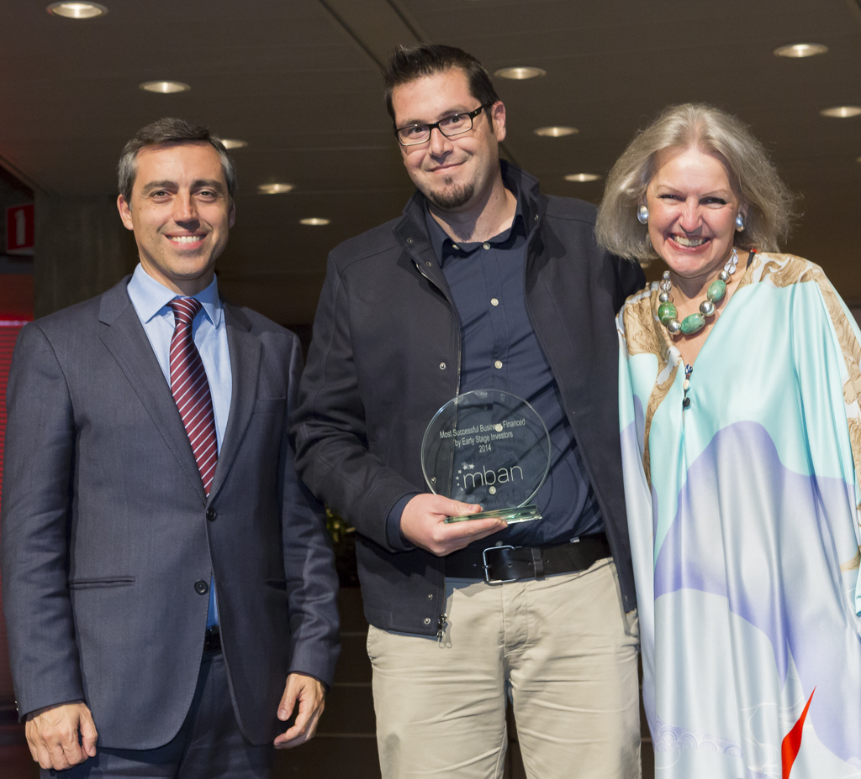
2. Best MENA Investor 2014: Arabreneur
Arabreneur is changing the Middle East early-stage eco-system with its investments in more than 20 companies throughout the MENA region. Congratulations!
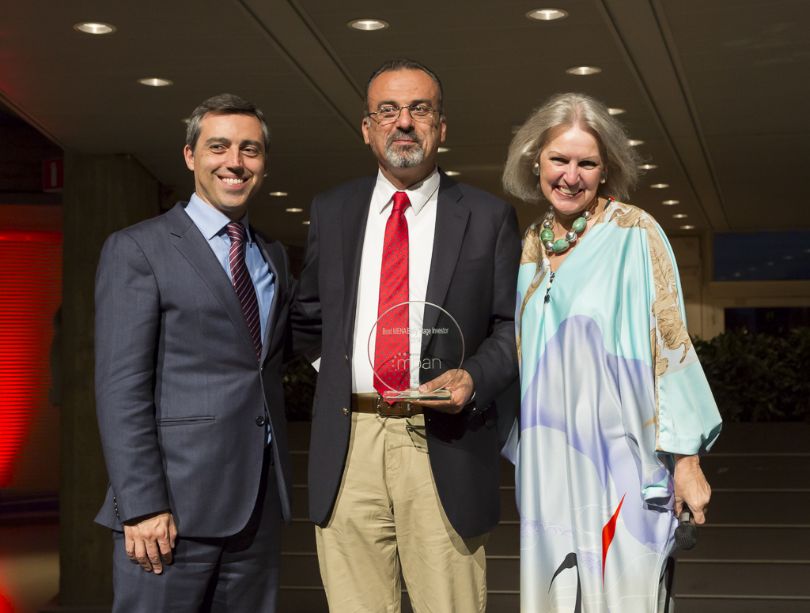
Special Recognition Awards were given to:
1. The EBAN Impact Investing Committee
The EBAN Impact Investing Committee under the leadership of Hedda Pahllson-Mohler has been indefectible in bringing investing for good to Europe and the world. Thank you!
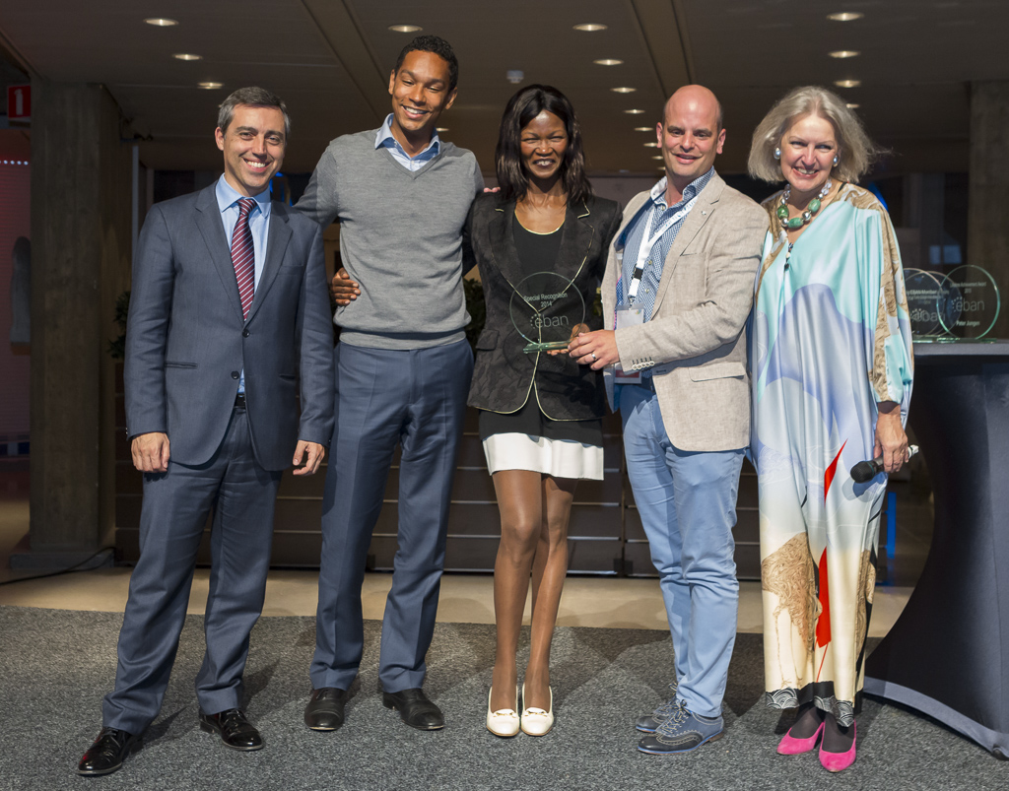
2. High Tech Campus
Not only does the High Tech Campus have a great facility for Conferences and Congresses, their enthusiasm and support of the entire entrepreneurial, innovation, and early-stage investment eco-system make them stand out in the world!
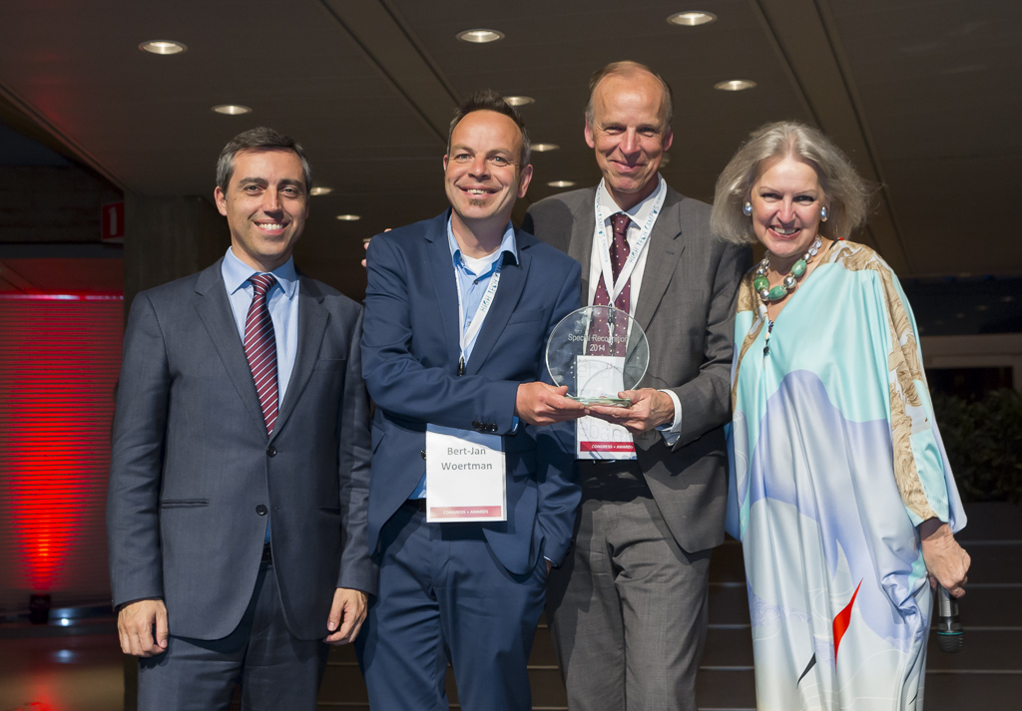
To conclude the ceremony Candace Johnson, President of EBAN, said: “It is a privilege to host the European Business Angel Congress and to highlight the important role of business angel investment as an asset class. We are continually working to accelerate business angel activity globally and the speakers and attendees at the EBAN 2015 Angel Summit are sharing a wealth of knowledge and experience.

